Checkboxes

* What is a CheckBox

The checkbox is a GUI element that allows the user to make certain choices for the given options. Users may get a list of choices, and the checkbox records the choices made by the user. The checkbox allows users to select either single or multiple choices out of the given list.

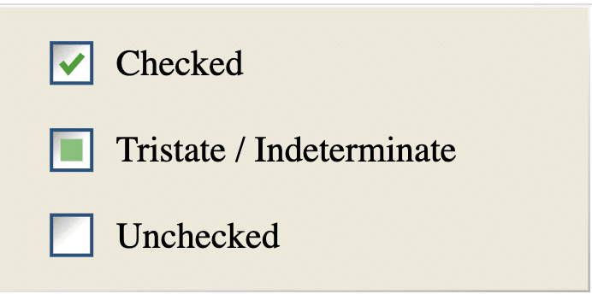

*How to perform validations on a CheckBox using Selenium WebDriver?*

***Selenium WebDriver***provides certain methods that we can use for a *pre and post validation* of the states of a ***CheckBox***. Few of these methods are:

*isSelected(): Checks whether a checkbox is selected or not.*

*isDisplayed(): Checks whether a checkbox displays on the web page or not.*

*isEnabled(): Checks whether a checkbox is enabled or not*

*We can use these methods to validate the current state of the check boxes. E.g., to validate that after clicking the checkbox, whether we have checked or not, we can use the “isSelected()” method. In other words, it helps to validate the current state of the checkbox. Similarly, before clicking a checkbox, we can validate that whether is checkbox is displayed on the page and is enabled, then only click on the checkbox. So, such pre validations can be done using the “isDisplayed()” and “isEnabled()”* ***methods.***

**Key Takeaways**

* *CheckBoxes are denoted by <input type=”****checkbox****“> HTML tag*
* *We can identify the Checkbox elements by locator strategies such as id, XPath, CSS selector, or any other selenium locator that can uniquely identify the checkbox*
* *We can select a checkbox either by using the click() method on the input node or on the label node that represents the checkbox.*
* *Selenium also offers validation methods like isSelected, isEnabled, and isDisplayed. We can use these methods to make sure checkboxes are in the correct status before performing any operation.*

**Radio buttons**

***Radio Button*** is an [***HTML***](https://en.wikipedia.org/wiki/HTML) element, which allows the user to select only one of the given options. We generally organize Radio buttons rally organized in a group that contains mutually exclusive options. That is to say, we can select only one option out of the give options.

Similar to Checkboxes about validations